This document provides the necessary instructions for completing the Week 5 lab exercises.

Exercise 1: Recursive call stack

In this exercise you will use the Debug tool in Eclipse IDE to view the call stack of a recursive method.

Open the Lesson5Examples project in Eclipse. Open the Factorial.java file. Set a breakpoint to line 40 (return n * factorial(n-1);)

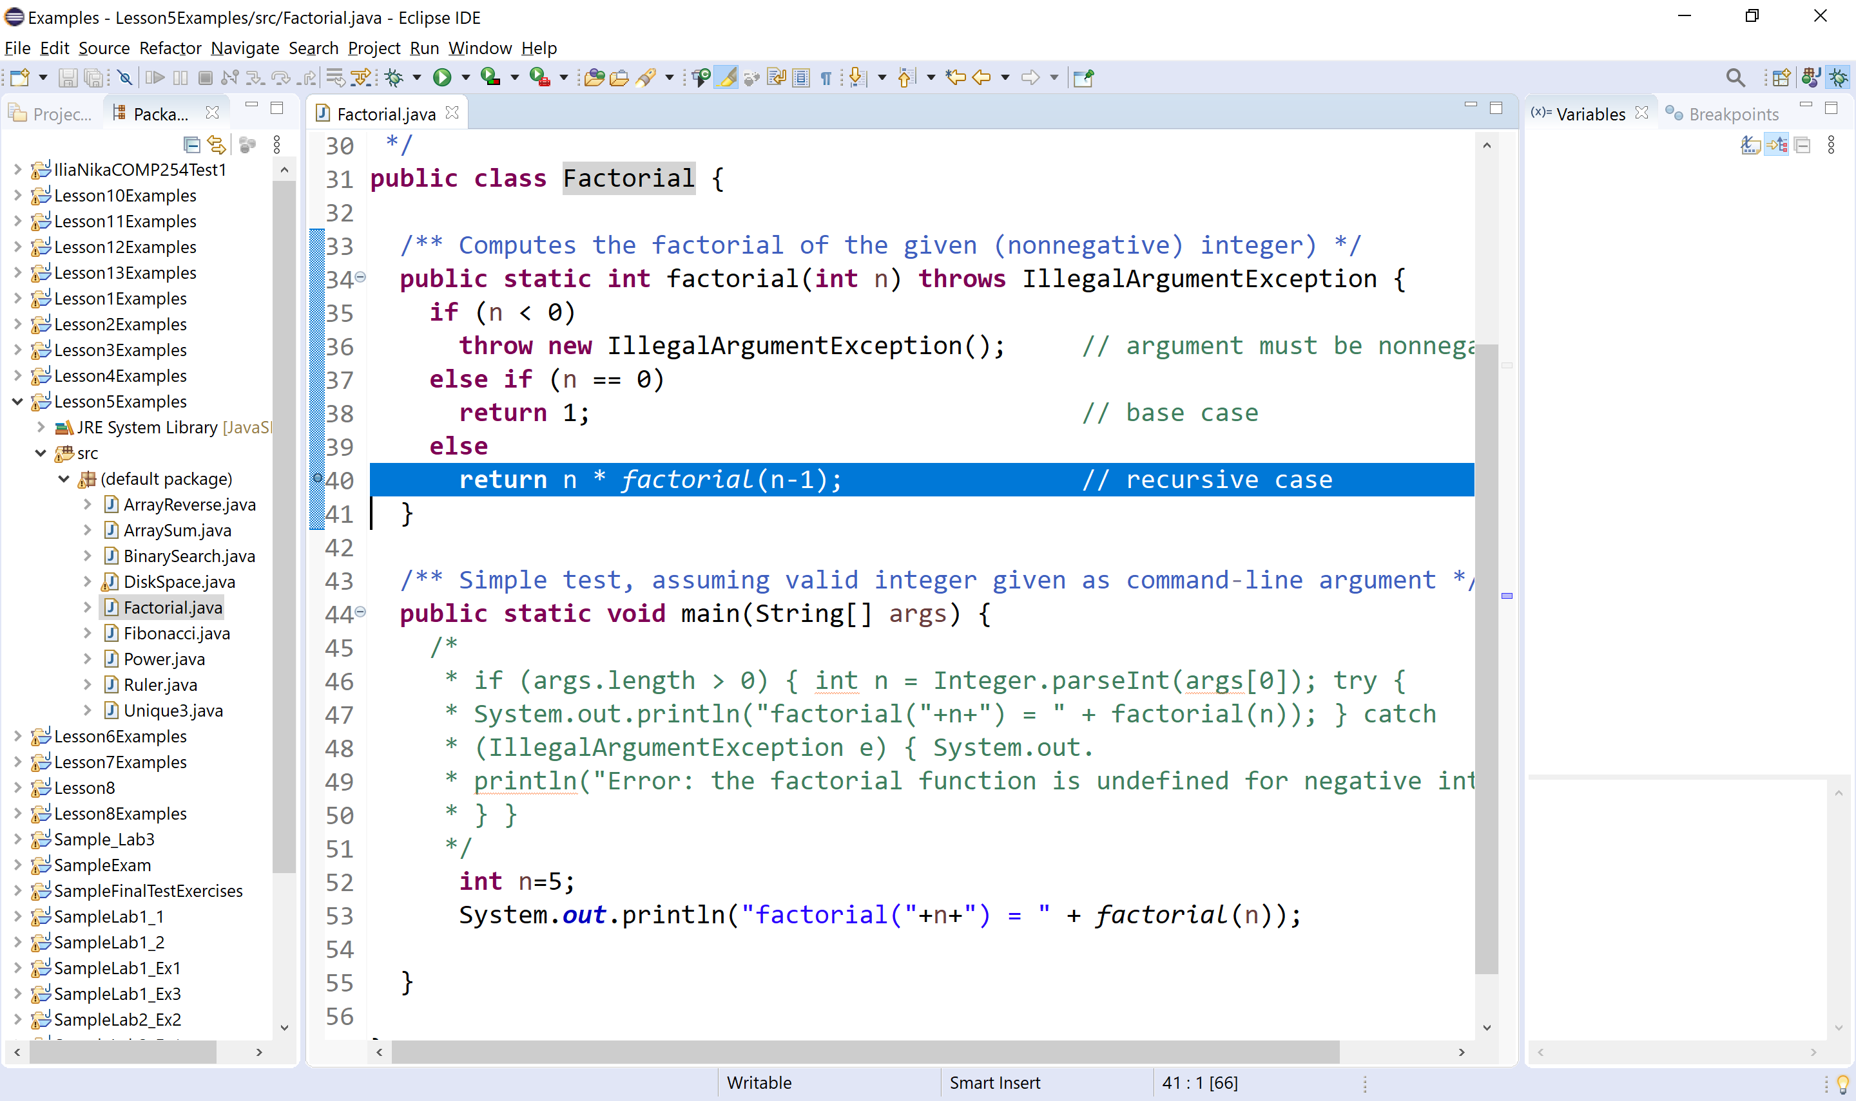

Run the debug tool as shown below:
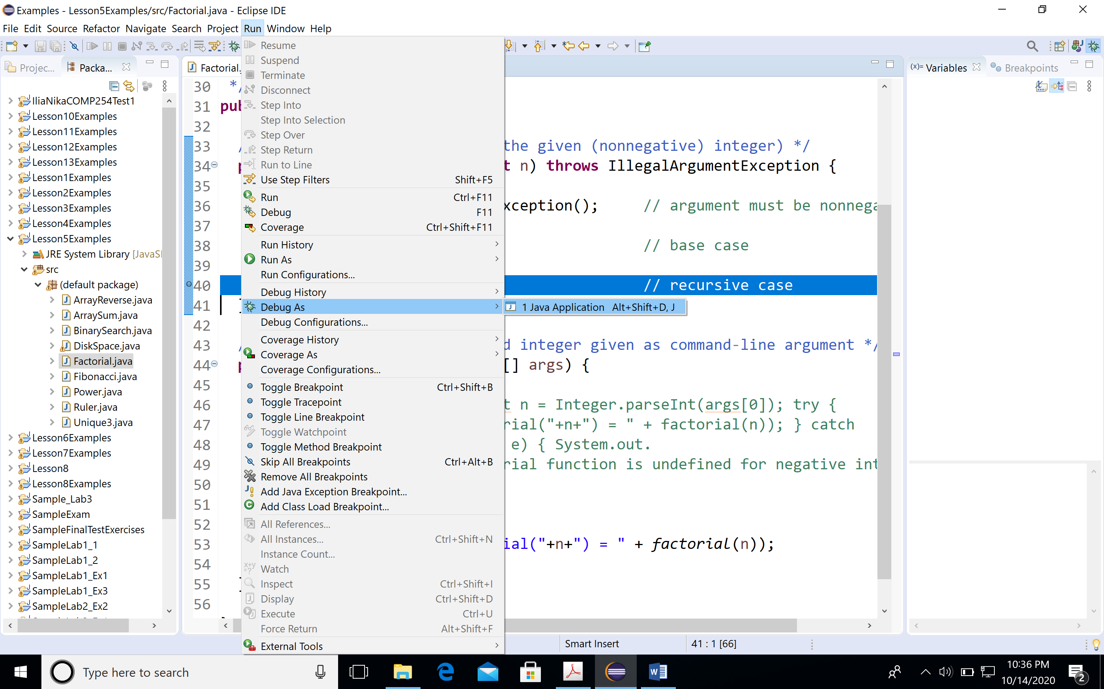

Select Run menu, then Debug As Java Application.

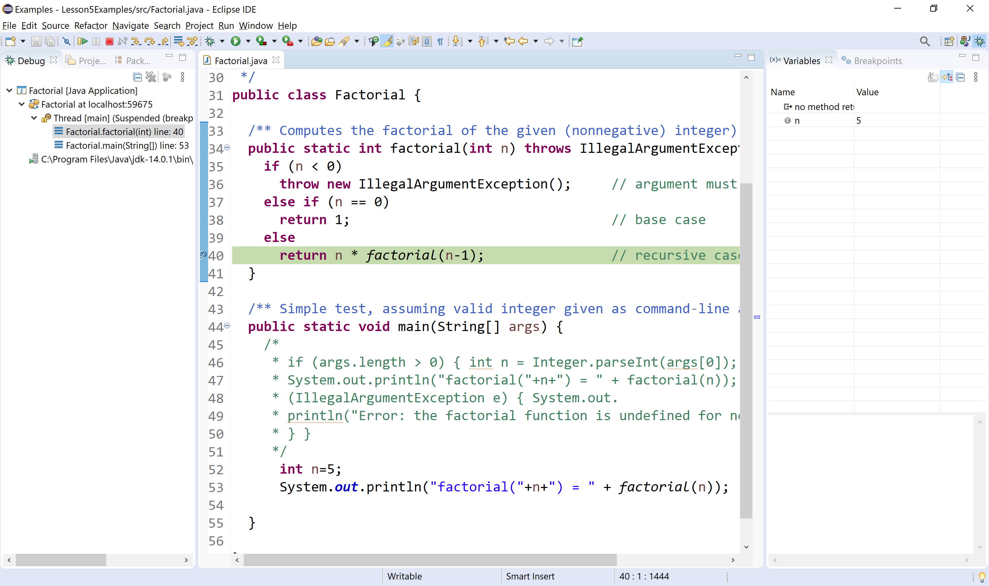
Note the call stack on the left pane.
The call stack contains the following information:
- Arguments passed to factorial method
- Local variables of the method ( local variable is n)
- The line number where the method returns

Note the value of variable n in Variables window. The value of n is 5.
Press F6 to step over and check again the value of n. The value of n is 4.

Keep pressing F6 until the method returns and capture the values of n and the return values.

Explain the steps.

Exercise 2: Maximum Element in an Array

Let a be an array of integers. The length of array is n. Using the same technique as the one used in linearSum algorithm from Lesson5Examples, write a Java method maxElement, that uses a recursive algorithm to find the maximum element in a. Feel free to use Math.max function from Math class.

Visualize the call stack of the maxElement method as described in exercise 1.

Exercise 3: Recursion Trace

- Draw the recursion trace for the execution of maxElement from exercise 2 on array a = 10, -2, 0, 7, 11, 8, 5, 6. -5, 13.
- Draw the recursion trace for the execution of binarySearch method from Lesson5Examples on array a = 2, 7, 8, 12, 14, 17, 21, 23, 29, 35, 37, 38, 39, 41, 45. Use target = 37.
Use the same format as in Lesson 5 slides.

Exercise 4: Performance of Recursive Algorithms

Determine the performance of maxElement algorithm in terms of O( ) notation.

